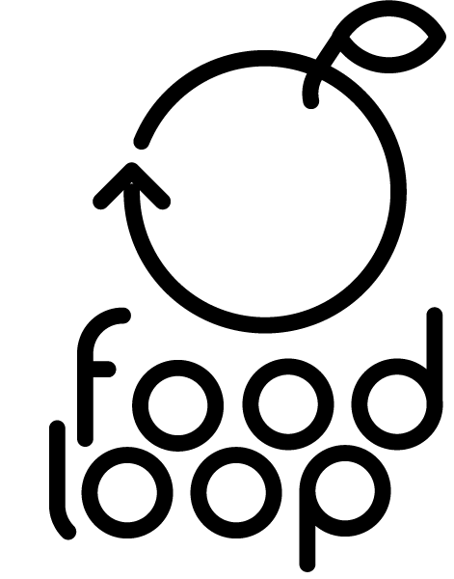
Food Loop
Summary Report

A summary research report completed for the Department for Environment, Food and Rural Affairs by the Policy Studies Institute and SEED Foundation

May 2013
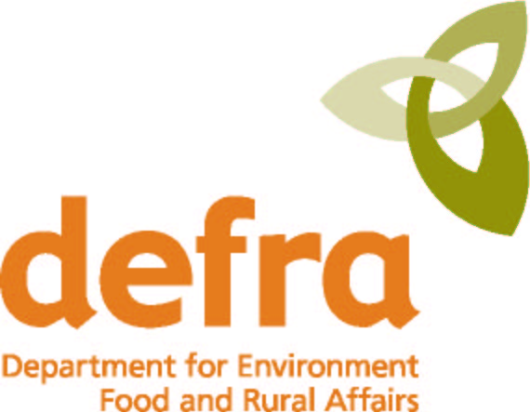

Department for Environment, Food and Rural Affairs
Nobel House
17 Smith Square
London SW1P 3JR
Tel: 020 7238 6000
Website: www.defra.gov.uk

© Queen's Printer and Controller of HMSO 2007

This publication is value added. If you wish to re-use this material, please apply for a Click-Use Licence for value added material at:
http://www.opsi.gov.uk/click-use/value-added-licence-information/index.htm

Alternatively applications can be sent to Office of Public Sector Information, Information Policy Team, St Clements House, 2-16 Colegate, Norwich NR3 1BQ; Fax: +44 (0)1603 723000; email: hmsolicensing@cabinet-office.x.gsi.gov.uk

Information about this publication is available from:
Centre of Expertise on Influencing Behaviours
Defra
Zone 5C, 5th Floor, Ergon House
c/o Nobel House, 17 Smith Square
London SW1P 3JR

Email: CEIB@defra.gsi.gov.uk

Published by the Department for Environment, Food and Rural Affairs
Food Loop

Summary Report for the Department for Environment, Food and Rural Affairs

May 2013

Suggested citation for this report:

McGeevor, K., Watson, B., Brass, C., and Bowden, F. (2013) Food Loop: Summary Report for the Department for Environment, Food and Rural Affairs. Policy Studies Institute. Defra, London.

This research was commissioned and funded by Defra. The views expressed reflect the research findings and the authors’ interpretation; they do not necessarily reflect Defra policy or opinions.

Policy Studies Institute  50 Hanson Street  London  W1W 6UP | SEED Foundation  20 Dudley Court  London  NW11 6AE
Corresponding author: Ben Watson (b.watson@psi.org.uk)

The project team
Food Loop was a collaboration between the following lead partners:
- SEED Foundation, a social enterprise that explores and promotes new design approaches to meet the challenges of sustainability;
- The Policy Studies Institute (PSI), a research institute based at the University of Westminster;
- The London Borough of Camden (LBC), the local authority responsible for delivering public services to the residents of the predominantly council-owned Maiden Lane Estate;
- East London Community Recycling Partnership (ELCRP), the community composting organisation responsible for the management of the Rocket composter on Maiden Lane.
The nature of our project meant we also worked very closely with a number of other groups active on Maiden Lane. In particular, this included the staff and volunteers at the Maiden Lane Community Centre (MLCC, as well as the following groups and organisations:
- The Maiden Lane Estate Management Board (or EMB), the tenant organisation that is elected by local residents and influences how the Council implements policies on the Estate;
- The Rocket Project Board, made up of representatives from the research team, ELCRP, MLCC, the Maiden Lane Community Enterprise, LBC’s Sustainability and Housing and Adult Social Care (HASC) teams, and local residents;
- The Maiden Lane Community Enterprise, a social enterprise that works closely with the Community Centre and runs contracts it has won from the London Borough of Camden (including maintaining green spaces around the Estate).
Finally, we worked with Sean Miller, a service designer, and Mathias Gmachl and Rachel Wingfield from Loop, a London based art and design studio.

Acknowledgements
The project Food Loop involved a number of different people, all of whom the project team are indebted to. In particular, we would like to thank:
- David Wilson, Sustainability Officer at London Borough of Camden (LBC);
- Marc Howard, Consultation and Engagement Officer at LBC;
- Sean Miller (nonon), for teaching us so much about service design;
- The staff and volunteers of the Maiden Lane Community Centre and Maiden Lane Community Enterprise, particularly Marion Pike, Dave Walters, and Les Coughlin;
- Our Defra research managers, Jan Jackson, Andrea Collier; and Veronica Sharp for managing this report to completion;
- East London Community Recycling Partnership (ELCRP), particularly Sheila Kearney, the Maiden Lane Rocket Manager;
- City Leaf, for advice on urban food-growing;
- Mike Buffington from SEED Foundation;
- Mathias Gmachl and Rachel Wingfield from Loop;
- Belinda Abbott (Design London) and Dejan Mitrovic (SEED Foundation) for our lovely project film; and
- Ashley Slisz for help with editing.

Finally, and most importantly, we would like to thank all the residents of Maiden Lane who worked with us on the project, and on whose ideas and insight much of our work draws.
Introduction
Food Loop was an action-based research project funded by Defra’s Centre of Expertise on Influencing Behaviour (CEIB). It was designed and delivered by the Policy Studies Institute (PSI), SEED Foundation and the London Borough of Camden (LBC), together with a local community waste service provider.
Food Loop tested how ‘co-design’ (a design-based approach that involves people in the development of effective solutions to problems) can be used to help residents and Council staff design a closed-loop food waste system, in which food waste was collected, composted and used to grow fruit and vegetables. Central to the project was a Rocket composter, an in-vessel composting machine which speeds up the natural break-down of food waste into compost (see Box 1).
Figure 1: Our 'Food Loop'
The overall aim was to provide an easy way for residents to separate their food waste by making the results of their actions visible, useful and enjoyable. It ran on the Maiden Lane Estate in North London between March 2009 and November 2010. The project sought to address two hypotheses:
- A food waste service would operate more effectively if designed in collaboration with those who use the service; and
- The best way to get people to care about food waste is by making the local benefits of recycling and composting visible.
The project was delivered through five research objectives:
- To facilitate the roll-out of a food waste recycling scheme, by co-designing communications materials with residents;
- To work with residents to identify issues with the service and to co-design appropriate improvements to the service;
- To work with residents in the setting up of a community food-growing scheme to create a connection between food waste, compost and food-growing;
- To assess the value of co-design as a tool to understand and respond to the needs of local residents;
- To evaluate the co-design process and understand how this impacted on the acceptability and effectiveness of the scheme.
Box 1: What is a Rocket composter?
A Rocket composter is in an in-vessel composting system, which uses the heat generated by natural decomposition processes to sterilise food waste, allowing food waste that includes meat, fish and other materials to be rendered safe and compliant with Animal By-Products Regulations (ABPR). Food waste is added to the Rocket mixed with woodchip (or other organic matter), and is left in-vessel for two weeks. During this time it is regularly rotated (by a mechanical fin) and excess water, which makes up around 50-60% of the food waste, is extracted from the Rocket. The resulting sterilised product then has to be left to season for 6-8 weeks (either in a container or open storage facilities). Once seasoned, it can be mixed with soil (at a 1:1 ratio) and is ready to be used as compost.

What is co-design?
This research project adopted and tested ‘co-design’ as an innovative participatory process. Co-design (or ‘collaborative design’, ‘co-production’ and ‘participatory design’, as it is also variously known) is an emerging design discipline, employed as an innovative approach to tackling some of society’s most complex and deeply rooted problems. It is generally applied in services (prominent past examples include reducing recidivism among prisoners, or improving access to and reducing stigmas around NHS sexual health services), where a series of design interventions across different stages of that service can enhance the user’s experience of it. Through closely observing the way people use services at different moments in time, facilitating collaborative workshops and creating visual maps and diagrams, the co-design process has been shown to make services work better and improve people’s experiences, whether those people are delivering or using the service.
The innovation in co-design lies largely in its process. Co-design is a participatory, collaborative design process whereby the views, inputs and skills of people with many different perspectives are used to address a specific problem (Demos 2008: 17). The essence of its approach is to build inter-disciplinary design teams, led by professionally trained designers, but importantly, also incorporating members of the public, product and service users and professionals from any relevant discipline, to first of all accurately define the project brief and then to collaboratively create new solutions, with the benefit of first-hand user experience and insight.
Setting up the Food Loop project
Food Loop’s focus on the Maiden Lane Estate came about as a result of a local authority decision to pilot an organic waste scheme on the site. Prior to this, waste and recycling services on Maiden Lane were limited. Residents took their municipal (i.e. non-recyclable) waste to communal ‘Biffa-style’ bins, located at various points around the Estate. Recycling was taken to mini recycling centres (bring sites), located at different sites from the standard waste bins. Tins, cans, glass, plastic bottles, and paper and cardboard could all be recycled in these bins. Figures from the early part of 2009 suggested Maiden Lane produced approximately 524 tonnes of residual waste per year and recycled 124.9 tonnes, or 2.4 tonnes per week. This suggested a recycling rate on the Estate of approximately 20%, compared to an average across Camden of 28% and a national average of over 35%. Although a doorstep recycling collection was trialled by the Council several years prior to this project, the service was withdrawn after a two-year period due to a lack of funding.
The installation of the Rocket was tied to the regeneration of the Estate more widely, as a means of symbolising LBC’s commitment to investing in Maiden Lane. The LBC report which proposed the Rocket’s installation stated that Maiden Lane was specifically chosen because ‘Maiden Lane is one of four estates included in the first tranche of Camden’s Estate Regeneration projects. On Maiden Lane, officers have been working at the grassroots to engage local people with the Estate regeneration agenda by building trust and trying to change the negative views that many residents have of the council. This approach is undoubtedly beginning to have some impact and commitments to invest on the Estate need to be carried through if Camden is to continue to win local hearts and minds’ . Evidence suggested residents were also in favour of a new food waste scheme: when residents on the Estate were surveyed and asked ‘Would you use a food waste recycling facility? 76.4% of respondents were in favour (with 20.9% against and 2.7% giving no answer).
In early 2009, LBC awarded the contract for the running of Maiden Lane’s food waste service to a local community enterprise. Soon afterwards, LBC set up the Maiden Lane Rocket Board to oversee the project, made up of local groups with an interest in the Rocket scheme (including representatives from the research team, the Maiden Lane Community Centre, LBC’s Sustainability and Housing and Adult Social Care teams, and local residents).
Box 2: About the Maiden Lane Estate
The Maiden Lane Estate forms an isolated cul-de-sac immediately to the north of the King's Cross railway complex in north London. It is composed of low-rise blocks of flats. avenues with terraced housing, a central community centre and some green spaces. It is situated within the London Borough of Camden and is home to 479 households. A 2008 survey of housing needs on the Estate found that 12.5% of respondents were unemployed, and a further 9.1% of respondents were long-term sick or disabled and unemployed. A comparison by ethnic breakdown revealed that a higher proportion of BME groups experienced an increased level of overcrowding on the Estate .
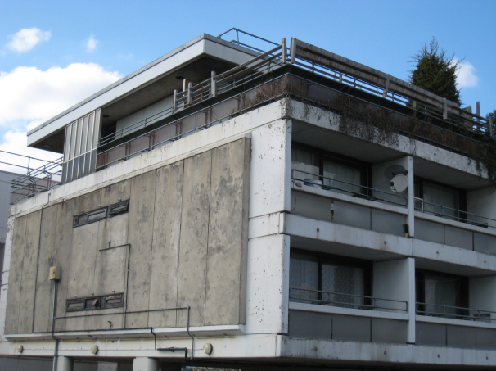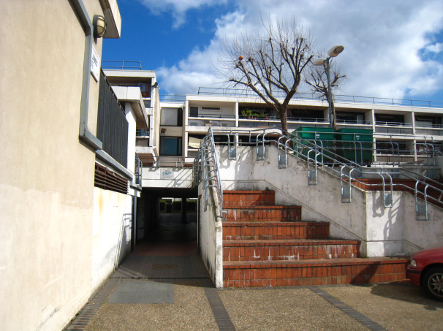
Figure 2: The Maiden Lane Estate, north London

Methodology
The project combined an action-based research methodology, with the processes of co-design, and used a mixed-methods approach to data collection. Qualitative data and insights were collected using a small number of surveys, workshops and focus groups, interviews with residents and other stakeholders, followed by an evaluation workshop with the Resident Design Team. Quantitative data was gathered to monitor participation.
Central to Food Loop’s co-design processes was a ‘Resident Design Team’ made up of a small group of around 11 participants from Maiden Lane with whom we worked closely for the duration of the project. Six workshops were held with the Resident Design Team, to co-design different aspects of the service including designing communications materials, making interventions to improve service delivery, and designing food-growing spaces. Participatory, design-based approaches were used with residents, including visual methods, hands-on drawing and making, scenarios-based approaches and games, as well as ethnographic methods, such as the use of disposable cameras.
When inviting Estate residents to workshops, we sought to recruit a mixture of male and female residents, a broad range of ages, and a mixture of residents from different national origins and ethnic backgrounds. We also sought to recruit from different types of family (e.g. with children / without children etc.) and different accommodation types. While we did achieve a good mix of residents at each of our workshops, there were some groups that we did not work closely with. For example, young people (18-25 year olds) and the elderly (60+) were not represented in our Resident Design Team, and only one teenager participated in the project (in the first two workshops). Members of the Resident Design Team tended to be middle-aged, and 11 out of 17 of the residents who participated in one or more workshops were female. It was also clear from the addresses of the Resident Design Team that none lived in the blocks of bedsits on Maiden Lane (see Figure 17).
We also worked closely with the local authority and service provider (including the shadowing of service operatives) to initiate and continuously evaluate and improve the service. When compost became available from the recycling of food waste, we worked with residents and other stakeholders to envision how it should be used, and helped to craft a plan for future food-growing on the Estate.
A table detailing the project methodology is laid out below, followed by a timeline of project activities.
Table 1: Summary of project methodology: activities and data generated
Activity and methods | Date; sample | Data type | Data robustness  (++ /--) and analysis
Design workshops
Workshop 1: designing communications. Facilitated discussions of photos taken by Resident Design Team using disposable cameras; activities designing communications materials including testing different communications methods, and producing posters and leaflets. | Jul. 2009;  8 residents | Qualitative (transcript, materials produced by residents); film | Data generated through in-depth discussions (++) and visual materials produced by Resident Design Team, including posters and leaflets (+). Qualitative analysis.
Workshop 2: stakeholder blueprinting. Service blueprinting workshop held with Maiden Lane stakeholders. The ways in which service users interact with the food waste scheme are identified, and areas with problems or potential for improvement are highlighted. | Nov. 2009; n/a | Qualitative (flowchart blueprint of service) | Formal blueprinting process, conducted by service design professional (+). An excel table ‘map’ of the service is produced (+), which is continually updated through an iterative process. Qualitative analysis.
Workshop 3: evaluating the food waste scheme. Facilitated discussions about food waste collection scheme. Small group activities to generate solutions to problems with scheme. | Nov. 2009;  11 residents | Qualitative (transcript, materials produced by residents) | Data generated through in-depth discussions (++).  Visual materials produced by Resident Design Team (+). Qualitative analysis.
Workshop 4: designing food-growing spaces. Short walk around open spaces on the Estate and discussion with residents, followed by facilitated discussions about food-growing spaces. Small group work, using scenarios-based techniques to generate design insight. | Feb. 2010;  11 residents | Qualitative (transcript, materials produced by residents) | Data generated through in-depth discussions (++).  Visual materials produced by residents (+), including diagrams showing residents’ visions for the future of Maiden Lane. Qualitative analysis.
Workshop 5: designing the rooftop garden. Expert workshop held with stakeholders in Maiden Lane green spaces, including LBC, MLCC and Maiden Lane Community Gardener. | Sept. 2010; n/a | Qualitative (materials produced by expert group) | Visual materials, aided by professional gardener and using a 3D model of the Estate and an architectural plan (+). Qualitative analysis.
Final evaluation workshop with Resident Design Team. Facilitated discussions held with residents who had formed the design team at various points throughout the project. | Oct. 2010;  11 residents | Qualitative (transcript, materials produced by residents) | Data generated through in-depth discussions (++). Visual materials produced by residents (+). Qualitative analysis.
Resident surveys
Launch event survey. Survey completed by residents at the launch of the Rocket, covering their attitudes to food waste, the food waste scheme and gardening (Appendix 4). | Sept. 2009;  27 residents | Quantitative (survey data), | Limited data collected (-). Some quant. analysis though sample size small, and those participating in scheme likely to be over-represented.
Door-to-door survey. Survey data collected through door-to-door surveying, covering the food waste scheme and community growing (Appendix 5). | Feb. 2010;  95 residents | Quantitative (survey data)Error: Reference source not found & open questions (qualitative) | Sample large but non-random (+). Quantitative analysis using SPSS.
Focus groups and in-depth discussions
Focus groups (x2). Discussion with different collection scheme user groups (participants and ‘drop-outs’) about their reasons for taking part in or leaving the scheme, their experience of the service and modifications that could be made to the scheme. | May 2010;  25 residents (17 + 8) | Qualitative (transcript of discussion) | Data generated through in-depth discussions framed around a discussion guide (++). Qualitative analysis of transcripts.
In-depth discussions. In-depth discussions held with two pairs of residents, focusing on non-participation in food waste collection scheme. | Jun. 2010;  4 residents | Qualitative (transcript of discussion) | Data generated through in-depth discussions (+). Qualitative analysis of transcript and researchers’ notes.
Celebratory planting day. Event to encourage communal planting and home growing on the Estate. | Jun. 2010;  ~ 30 residents | Qualitative (discussions with residents on the day) | Very limited data collected (-). Event focused mostly on raising awareness of Food Loop and community growing.
Stakeholder interviews with LBC Officers and MLCC staff, discussing overall project and evaluating success. | Nov. 2010;  2 LBC officers;  1 MLCC | Qualitative (in-depth interviews) | Data generated through in-depth, semi-structured discussions (+). Qualitative analysis of transcript.
Additional quantitative data collected
Participation data. Weekly data on the number of households participating. To participate, households must set out a caddy before 8am on Monday morning. | Sept. 2009;  Estate-wide | Quantitative (by household) | Robust (+). Collected by service operatives. Not externally verified though some support offered by qualitative research.
Food waste collected (kg per household), based on weekly random sample of ten caddies from the Estate. | Sept. 2009; Estate-wide | Quantitative (collection data) | Robustness unclear. Collected by service operatives but not externally verified.
Municipal waste collected. Recyclable and non-recyclable waste collected (April 09/10). | Apr. 2009/10; Estate-wide | Quantitative (collection data) | Directly comparable year on year but based on volume not weight (+).

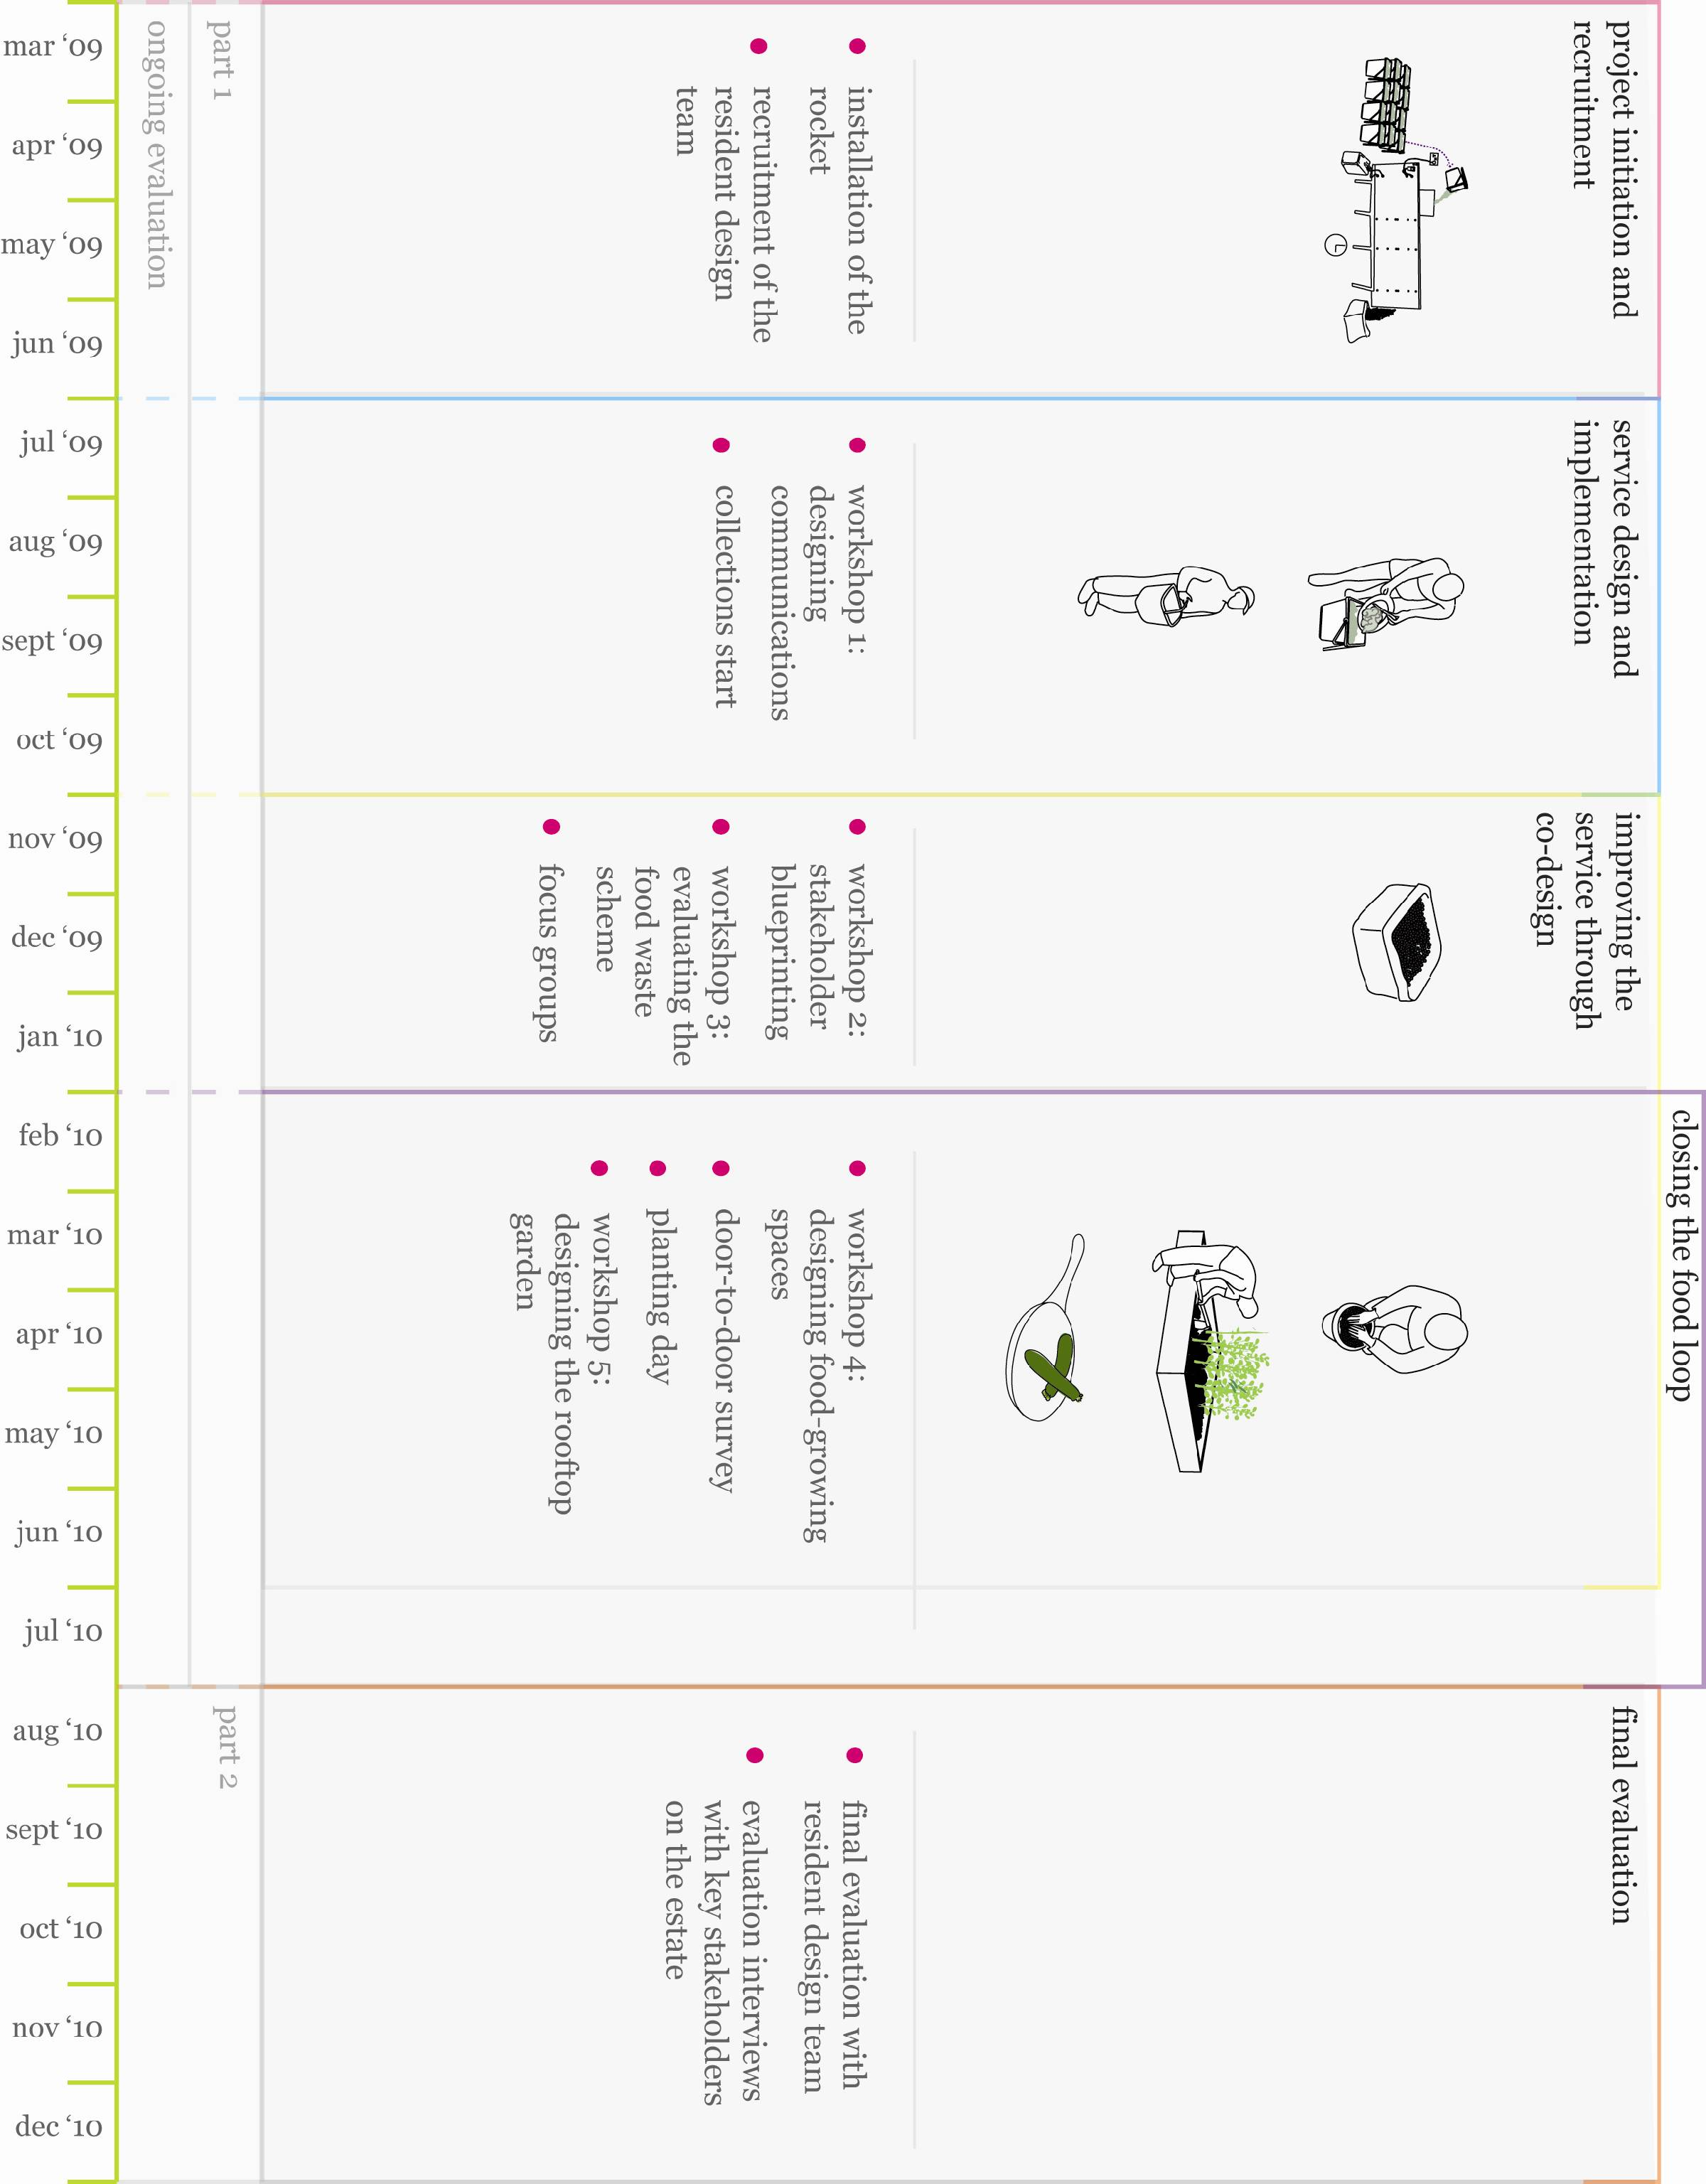

Project Scale and Limitations
Food Loop was a small scale, context specific pilot set in a low-rise social housing estate. The results are indicative rather than generalisable; they should be treated as providing valuable lessons relating to the development of a ‘closed loop food waste system’ rather than a model to be implemented elsewhere. As such, the limitations of the project reflect the small scale and qualitative nature of the project, and of action research itself. Specific limitations include:
- Co-design is often used to identify and frame societal problems, and to then define possible solutions. On Maiden Lane, this involvement in identifying and framing the problem and choosing the specific solution was not possible, as neither residents nor those ultimately responsible for delivering the service were involved in its initial conception. The problem (food waste on the Maiden Lane estate) and the service selected to resolve it (a small-scale service provider with a Rocket composter) were chosen by LBC before the residents had any involvement in the project. This is an important consideration, as co-design can involve the design of a service from the very basics to the finest detail. On Maiden Lane, the co-design process was limited to the later stages of service implementation and delivery.
- Engagement with the service provider was difficult, partly because of a lack of time provision in their contract with LBC for meetings. The service provider was also reluctant to make changes in its delivery model. This caused considerable difficulties in a project that relied on all parties participating and contributing to it, and made it difficult to implement the changes suggested by residents and other stakeholders.
- Participation data gathered was poorly suited to the needs of the project, leading to extensive supplementary data analysis. Data was also sometimes found to be inaccurate, and the number of households that refused a caddy was not recorded. The data collection methods also encountered practical problems that affected the robustness of the results.
- The project team worked very closely with the residents of Maiden Lane, colleagues at LBC and the Maiden Lane Community Centre. While every effort was made to remain objective in our assessment of the project, our proximity to all those associated with Maiden Lane may have made it difficult to objectively reflect on the findings and lessons learnt from our work.
- During the early stages of the research project on Maiden Lane, it became apparent that relations between many of the Maiden Lane residents and LBC were challenging. One important piece of context to this was that throughout 2009 and up until May 2010, LBC consulted with residents about the possible regeneration of the Maiden Lane Estate, involving the possible demolition of some sections of the Estate and the building of higher-density, modern housing in its place. The ongoing debate about Maiden Lane’s regeneration was a contentious and sensitive issue throughout the implementation of Food Loop.
- Despite our efforts, membership of the Resident Design Team tended to reflect residents’ level of interest in the project, with those who were supportive of food waste recycling tending to be easier to recruit to workshops. While we sought to avoid this, the nature of the research (including three-hour workshops at the weekend) meant that workshop attendees were perhaps unrepresentatively supportive of food waste recycling, with those who were less supportive dropping out of the Resident Design Team as the project progressed. As such, additional, small-scale recruitment activities were carried out on an ad hoc basis (for example, by contacting those who declared an interest in the project during the door-to-door survey) to ensure workshop attendance always averaged at least ten residents.

Making interventions in the food loop
Throughout the project, the research team made a number of interventions in the ‘food loop’ to improve the efficacy of the food waste recycling service and the use of compost on the estate. These interventions were planned or designed in collaboration with residents, the service provider, LBC and other stakeholders. A selection of these interventions can be found below; a longer list can be found in the full technical report:

Intervention 1: Improving external communications
Based on evidence showing that tailored communications campaigns are more effective at promoting participation in recycling schemes than non-tailored means (e.g. Enviros, 2007), the aim of this collaborative production process was to maximise the appeal of the communications materials used in the service. Leaflets about the food waste scheme were co-designed in our first workshop with residents and launched alongside the Rocket composter, prominently featuring a member of the resident design team and stressing local benefits that the residents design team had thought particularly salient. In keeping with the iterative nature of action research and co-design methodologies, after a year of use the materials were revised, incorporating further feedback and suggestions from residents. Art-work developed by children of the Resident Design Team during parallel workshops was also used in later communications materials, such as labels for bags of Maiden Lane compost.
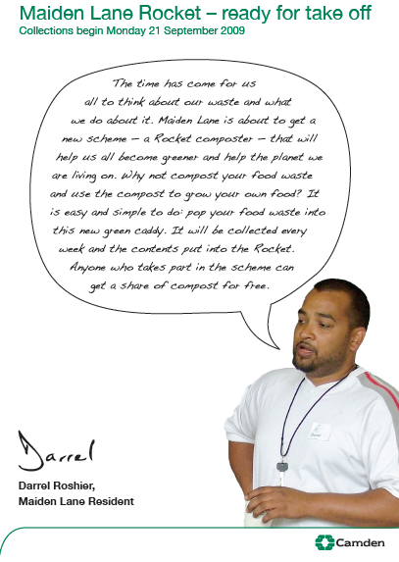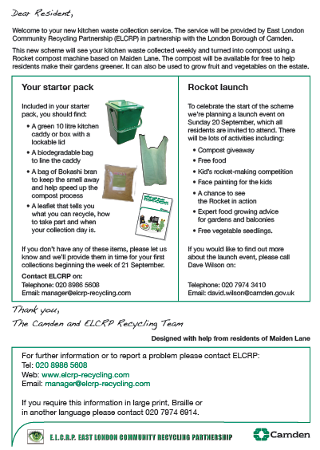
Figure 3: Cover letter given to all new participants in the food waste collection scheme.

Intervention 2: Improving the food waste collection service
The second workshop with the Resident Design Team focused on identifying problems with the service and proposing practical solutions to these issues, with information from the focus groups and door-to-door survey helped to feed in to this iterative process of improving the service design. The result was a mixture of communications, product design and service design interventions. Actionable improvements suggested by the residents related mainly to the provision of new caddy liners and Bokashi powder (used to speed the decomposition of food but also reduce bad smells). For example, participants requested that Bokashi and replacement caddy liners were posted through letterboxes rather than placed in them (as caddies were often wet or dirty), a change which the service provider duly implemented.

Intervention 3: Designing a ‘request dial’
The blueprinting and design team workshops revealed that residents were unsure how to communicate their needs to the service operatives on a weekly basis. It was agreed with Resident Design Team members and the service provider that a ‘communication tool’ should be developed to allow residents to communicate their needs to operatives on a weekly basis. In collaboration with residents and the service provider, a ‘request dial’ was designed and prototyped, based on indicator systems that are used on milk bottle holders, Once finalised, the dials were distributed across the Estate and attached to the caddies by the service provider’s operatives.
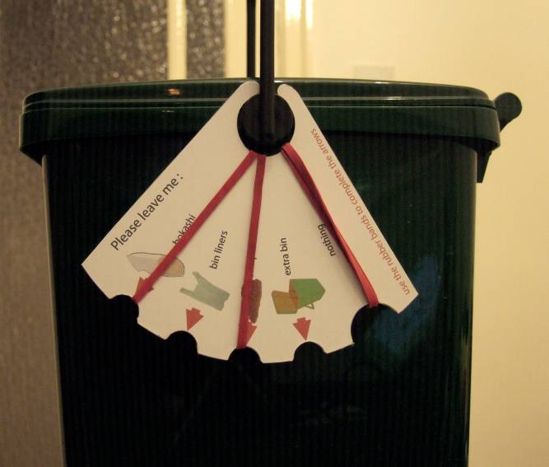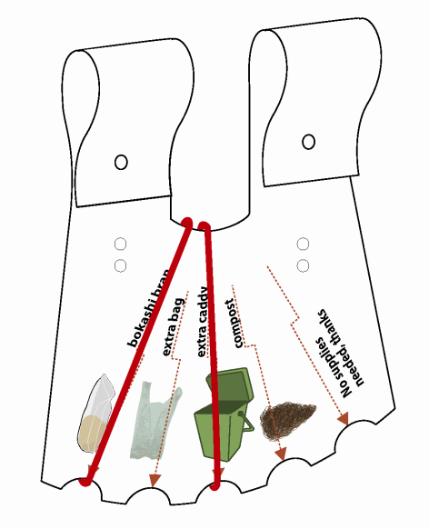
Figure 4: prototype for testing Figure 5: final dial

Intervention 4: Implementing a text message reminder service
During workshop 3 participants reported problems with remembering to put their caddies out the night before, in time for the early morning food waste collection service. Workshop participants suggested a text message reminder service as one way to overcome this problem. LBC already had an existing service agreement with a text message service provider that allowed the set-up of a text reminder service on Maiden Lane. The service was completely free for residents and enabled a two-way service, giving residents the option of sending free messages to request new bags and Bokashi as well receiving reminder texts. The service was trialed with 18 residents for 4 weeks before being discontinued, as it had little impact on the use of the service, and the council was discontinuing its contract with the text message service provider.

Intervention 5: Designing the rooftop food growing space
The fourth Food Loop co-design workshop was held at the Maiden Lane Community Centre in February 2010 to generate ideas for how the Maiden Lane compost could be used on the Estate, how the green spaces and food-growing could be managed and how the produce could be best used. Workshop activities included a tour of potential growing areas on the Estate and a scenarios-based exercise, in which participants worked in small groups to consider future food-growing models for the Estate and the ways in which these might be managed.
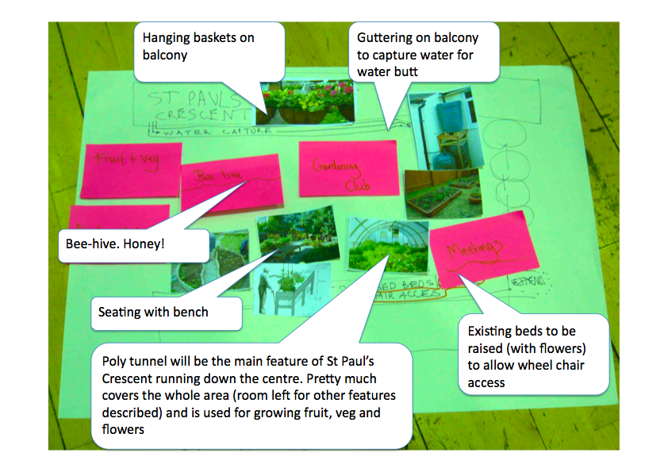
Figure 6: Residents’ ideas for use of the food growing space
In September 2010, having tested the viability of the Community Centre roof as a community food-growing space with a planting day, workshop five was held to design plans for a community garden on the rooftop space. Representatives from LBC, the Community Centre, the Maiden Lane Gardener and an expert from urban gardeners ‘City Leaf’ attended and contributed to the workshop. The two designs that emerged allocated half the space to food-growing and half to recreation, with an integrated hedgerow or living wall physically separating the two spaces.
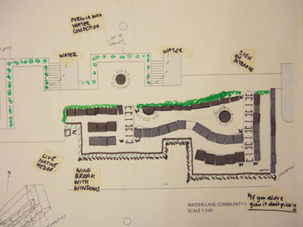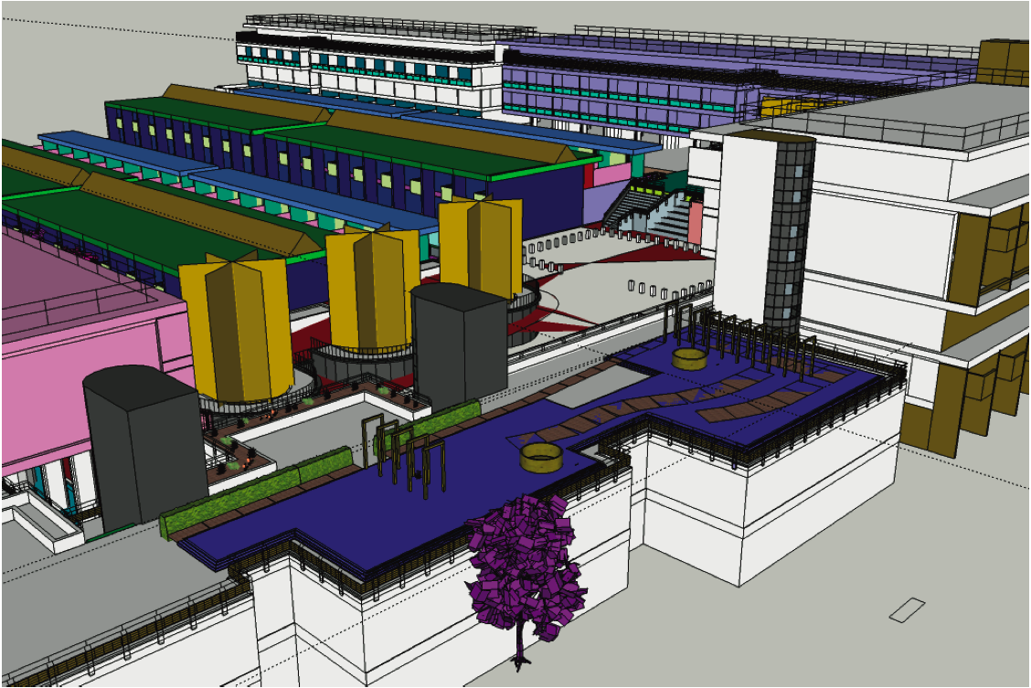
Figure 7: Photo of roof design Figure 8: 3D model of roof design

Key Findings
Food Loop was a challenging and yet inspiring project; it demonstrated the importance of a good and open relationship between statutory partners and the local community. It showed how user-led design and implementation can inspire and empower individuals in a small community to design their own solutions to collecting and composting food waste, and growing their own food.
Measuring the levels of participation in Food Loop was set against a backdrop of considerable challenges in service delivery and limitations in data collection. However, the results compare favourably with other types of food waste collection systems in social housing areas. Of the 234 households the average participation rate was 55% (if households are only included in the participation figures once they had been issued a caddy). For nearly the entire first year of the scheme’s operation, though, the service provider only delivered food waste caddies by door knocking and personal contact with residents. As door-knocking was conducted from 10am-4pm, this meant that by the end of April 2010 (week 32 of the scheme), only 234 of the 479 households on Maiden Lane (49% of households) had received food waste caddies. This limited the scope and impact of the food waste scheme considerably.
There were several findings arising from the design and execution of Food Loop that are detailed in the full report. Some of the key findings are listed here.
The research project showed several positive outcomes:
- The co-design process was particularly valuable for those directly involved in it, namely the Resident Design Team. Participation in the co-design project gave them a feeling that they were making a difference and having a positive influence on their estate, and also gave some of them a sense of ownership over the project and the food waste service. Their leadership created ambassadors within the wider community, added transparency, and led to positive ‘word of mouth’.
- Some residents reported feeling a sense of pride that they were doing their bit for the environment and helping to reduce food waste. Participation in the food waste scheme appears to have had a positive knock-on effect on recycling in general (although evidence was not collected on a direct causal link).
- The designs created through the co-design process were always tailor-made, addressing the specific concerns and creating unique solutions; with low tech solutions found to be especially effective (e.g. a ‘Request Dial’ - which was a simple tool for residents to indicate if they needed another caddy or more caddy liners - was considered a success by the residents, as opposed to a text messaging reminder service, which was used very little and discontinued). Prototyping residents’ ideas increased the saliency of communications and interventions
- When the residents were able to see and feel the compost, they felt that this validated the food waste collection scheme and would encourage greater participation. Residents cited numerous localised benefits of participating in the food waste scheme (e.g. reduced vermin, kitchen bins not smelling, and the use of compost to improve local green spaces) although general environmental messages seemed less salient with them.
Participation (and therefore effectiveness) in the scheme was hampered (and in some instances significantly) by various factors:
- The infrastructure of inner city estates is a barrier to the design and delivery of easy-to-use food waste recycling systems.
- The inflexible approach of the service provider (e.g. not delivering caddies to all residents and not recording participation data accurately) was problematic in implementing interventions, and the residents frequently cited the service provider ‘not listening’ as one of their main frustrations – and for some, their reason for ending their participation in the food waste service.
- On the other hand, the action research nature of the project meant the service provider was exposed to higher levels of scrutiny than more traditional approaches to consultation and service delivery. It is possible that this highlighted otherwise ‘invisible’ problems, and contributed to their lack of willingness to support the project.
- Residents often cited negative relations and low levels of trust between the Council and residents as a reason for being sceptical about local service provision. The ongoing regeneration of the Estate, which originally proposed the demolition of some parts of the Estate, meant that there were strong negative feelings expressed by residents towards the Council.
- The Rocket composter was situated close to properties and residents were initially affected by the smell from the machine, although steps were taken to rectify this as soon as it was realised.
- The local use of compost was cited by members of the Resident Design Team as ‘validating’ the scheme but the availability of the compost was not communicated effectively. It was also a long time coming – it was almost 6 months after food waste collections began that compost was ready for distribution.
- Residents were not fully aware that the project was a pilot and that their participation could affect the potential continuation of the scheme, and were disappointed when council funding for the scheme was withdrawn after two years.
- Seemingly small problems with the service, when allowed to build up, were enough to reduce (or prevent) participation because they were perceived as too frustrating or insurmountable by residents.

Conclusions
The overall aim of the Food Loop project was to facilitate the community-led development of a closed-loop food waste system, in which food waste was collected, composted and used to grow fruit and vegetables entirely on a low-rise social housing estate. There are several conclusions arising from the project. The key ones relating to our hypotheses are:
- A food waste service would operate more effectively if designed in collaboration with those who use the service.
Co-design is a valuable approach to employ when developing new services; it enables deep insights into the specific needs of the community, which are not otherwise possible; and it is a process that everyone should take part in to improve acceptance of a new service and willingness to promote the service among peers. However, scepticism towards local authority-led schemes in general (and towards other residents in the community) may contribute to the unwillingness of some residents to participate.
From our experience, the conclusions in using co-design in this scheme are:
- The success of co-design depends on the full cooperation of all project partners from the outset - steps need to be taken early on to ensure that all project partners are able to participate fully. This includes ensuring that there is time and resources to take part at a practical level. We found that the service provider in particular needed additional time and resources and should have been contractually obliged to participate in the project. It is vital to be clear upfront about what an action research project can achieve to improve a service, and ensure that all parties agree on what is feasible to implement.
- Co-design requires significant resource, flexibility and financial commitment from local authorities. The co-design process may well require more resources than traditional methods of consultation. However, the benefits provide deep insights beyond what is normally found through other forms of research or consultation. The ‘fluid’ nature of co-design means that local authorities have to adapt and keep funds in reserve for undefined project activities (though local authorities are currently under pressure to spend budgets held in reserve).
- Using co-design can help to build trust in service providers and commissioners, as participants are able to see that their suggestions were being listened to and acted upon. However, care needs to taken to ensure that residents’ views are not ‘drowned out’ by other stakeholders. An independent design professional can assist the local community in expressing their ideas and opinions in a ‘secure’ environment and is a means to ensuring the process is done well.
- If residents are involved in the scheme, through co-design, it makes it harder for others to criticise. However, those who do not feel they have been listened to in the past may view dialogue as futile and be reluctant to participate. As such, it is important to distinguish between residents’ perceptions of apathy (from those who have no interest in participation) and inefficacy (from those who have not been listened to in the past).
Finally, the co-design elements of this project did not involve residents until after key decisions (for example, about the installation of the Rocket composter) had already been made by the local authority Although this cannot be quantified, this may have had an impact on the level of involvement and commitment of residents early on. A ‘user-centred’ approach to planning and designing waste systems, which places the user at the heart of its development at the earliest stage, is critical.
- The best way to get people to care about food waste is by making the local benefits of recycling and composting visible.
Of significance, the residents found compost to be inspiring and a valuable local resource. The natural decomposition that turns food waste into compost (via the use of the Rocket composter) captured residents’ imaginations, particularly when they were able to see and feel the compost. Residents also identified numerous localised benefits as part of their engagement in Food Loop (e.g. reduced vermin, kitchen bins not smelling).
Involving residents in the design of food growing spaces builds a sense of ownership and value in the use of compost to improve local green spaces. However, the sustainability of food-growing projects depends on capital support and ‘formal’ food management structures to provide the long term levels of time and commitment required (e.g. co-operatively managed allotment type schemes). The Maiden Lane Community Centre was very important in co-ordinating the activities of various groups operating on the estate, and provided a physical space for meetings and workshops. A well organised and resourced local community hub can be very important in increasing the efficacy of locally-run community services.
Other conclusions from our experience are:
- One size does not fit all – a flexible service system model that caters for different household and housing types is desirable (e.g. larger caddie sizes for families and allowing residents to drop off their food waste at central collection points). Some residents demonstrated a capacity to compensate for failings in the service through their own innovations. This innovative thinking also emerged in the workshops we ran to improve the service.
- Effective communication channels between the providers of the service and its users were a critical factor in the food waste-recycling scheme. Residents stressed the importance of identifying seemingly minor errors (e.g. providing the wrong sized caddy liners to residents) and rectifying them. In addition, formal, accessible channels of communication between users of a service and its provider are necessary to make a service responsive and flexible. The problems service users had in communicating their needs to the service provider were repeatedly mentioned by residents.
- The location of the composter is important. Aside from site issues such as access to water, electricity and heating, there was an issue with the smell from the processing of food waste.
- A ‘collective norm’ could be generated through the use of block or street competitions, particularly in areas where there are strong community networks. However, this requires participation data to be collected that enables comparative analysis. While residents were enthusiastic about the research team trialling this, the problems experienced in trying to alter the service provider’s model of delivery reduced our time available for doing so.
- Our experience of working in Maiden Lane illustrates the importance of preparing a detailed plan and communicating it clearly. This needs to be agreed upfront by all stakeholders. It was especially important to ensure that the local context, especially the local relationships, existing groups and local expertise, were understood and valued.

Action-based research
Action research helps challenge the misconceptions of research as being too ‘academic’ and not engaged enough with communities. Coupled with a co-design approach, it can offer additional insight by enabling the analysis of a service in a systematic way which helps to identify low cost service improvements. However, the iterative nature of action research means that it can be very time and resource intensive (e.g. our project team underestimated the number of meetings and steering groups it would be necessary to attend). In-depth research such as this also exposes service providers and community organisations to higher levels of scrutiny than usual. Whilst providing valuable insight it can pose a perceived threat to the organisations whose actions are being observed.
Implications
Our research has led to a number of implications for both policy and future research. In summary these are:
- Ensuring user-centred waste systems are integral to the design and planning of communities to overcome the infrastructural barriers encountered in inner city estates.
- Using co-design and service design as a means of better understanding how to effectively deliver public services, and gain community support for new services. This should include the placement of ‘designers’ within local and national government.
- Encouraging local authorities to (a) seek flexibility in service provision, in light of the fact that one service model will not suit all users, (b) include time for community engagement in service contracts, and (c) monitor and evaluate the wider social and community benefits of community waste and composting schemes.
- Promoting food waste as a productive resource to food growing may enable several pro-environmental behaviours to be promoted simultaneously (e.g. the avoidance of food waste, the recycling of food waste and the promotion of local, seasonal food).
- Making it easier for local communities to secure vacant land to secure provision for local, closed-loop resource systems. Ensuring communities have space to meet, network and collaborate can also be important in encouraging participation in food waste services. Furthermore, communities may need help in establishing management systems (for example, in food growing areas) which catalyse local leaders into action while remaining inclusive to others.
Priority areas for research are:
- To explore how co-design can be used in new communities and the regeneration of existing housing to ensure that domestic waste and recycling services are integral to the design of the built environment and understand how the existing infrastructure can be adapted or retrofitted. A ‘user-centred’ approach to planning and designing waste systems to reduce food waste is crucial.
- To explore how co-design can be used in other ‘local loops’, for example the way in which other resource cycles can be visualised within communities (e.g. linking of water consumption with local watershed or catchment areas). Co-design enables deep insights into specific community needs, which are not otherwise possible.
Other areas suggested for future research are to understand:
- The way in which the aspirations of those on lower incomes may conflict with defined ‘sustainable lifestyles’, and the way in which sustainability can be promoted in the context of social justice and equity.
- The relationship between attitudes to local authorities and how these attitudes correlate with willingness to participate in voluntary, council-led schemes.
- The relationship between a sense of neighbourliness and how this relates to willingness to participate in local environmental services like food waste recycling schemes.
- The links between different models of community food-growing and the communities in which food projects may operate, and the level of resources necessary to implement them.

The legacy of Food Loop
After the initial work at the Planting Day, the MLCC Community Enterprise (led by the Estate’s volunteer Community Gardener) continued to tend and water the plants, with some help from the Estate’s volunteer gardening club. The majority of food planted reached fruition, and residents who had been involved in the Planting Day or Maiden Lane’s gardening club were encouraged to harvest the food. Based on the designs drawn up during the Food Loop project, a successful grant was submitted to the Big Lottery Fund which has allowed the redevelopment of the roof of the community centre into a food growing area. At the time of writing, building work is still ongoing.
In September 2010, the London Borough of Camden took the decision to end the trial of the Rocket composter on Maiden Lane. The decision was taken on the basis of low participation rates and the cost of running the scheme. Under the conditions of the pilot, LBC agreed to hand over the capital associated with the scheme – including the Rocket composter and the caddies – to Maiden Lane’s Community Centre, on the condition that a financially-viable proposal could be put forward for how the scheme could be run. In December 2011, ‘Food Loop’ was launched as a social enterprise, and weekly food waste collections have continued, run entirely by resident volunteers on the estate with the help of the SEED Foundation. Maiden Lane compost (branded as ‘Plantify’) is now being sold in an attempt to make the scheme self-sustaining.

References
Boyarsky, A. and J. Winter (1983). " Maiden Lane. Housing, Maiden Lane, Camden, London; Architects: Camden (London Borough). Architects Dept, project architects: Gordon Benson and Alan Forsyth." Architectural Review 173 (1034): 22-29.

Hillier, B., L. Jones, et al. (1989). The architecture of the Maiden Lane Estate: a second opinion. London, University College London.

London Borough of Camden (2008). Options for a pilot organic waste scheme at Maiden Lane.

London Borough of Camden (2008a). Maiden Lane Housing Needs Survey 2008.

Hilary Cottam Prisons project. http://www.hilarycottam.com/?page_id=23. Last accessed 25th October 10.
Dott 07: Design and Sexual Health. http://www.designcouncil.org.uk/our-work/challenges/Communities/Dott-07/Dott-07-case-studies/Design-and-Sexual-Health/. Last Accessed 25th October 10.

